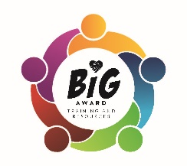
BIG Award Training and Resources
Focus on Mental Health and Wellbeing - Training Menu 2019/2020

Online Courses
Professionals
NCFE Level 3 Accredited Qualification – Anti-bullying Mentoring of Young People £199
NCFE Level 4 Accredited Qualification – Certificate in Anti bullying Mentoring of Young People £249
Students (14 – 21)
NCFE Level 2 Accredited Qualification – Certificate in Peer Mentoring £95

In house training
Staff
How to recognise and effectively deal with bullying – 1hr twilight or 2 hr CPD (cost to be agreed depending on numbers/travel)
Girl Bullying and Friendship Issues – 1hr twilight
E Safety and Cyber Bullying – 1 hr twilight
Lunchtime Supervisor Training Session – 1hr after lunch

Pupils
Peer Support Training Session – 2 hours
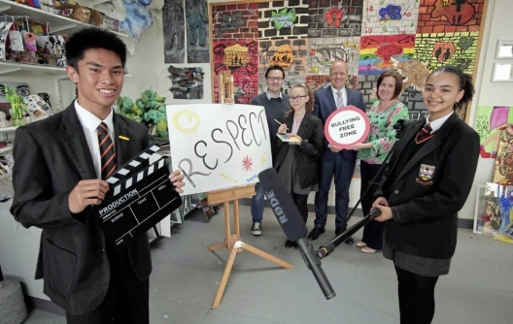
Peer Mediation Training – 2 hours
Class Friendship Workshop – 1 hr
Whole school anti-bullying roadshow – 1 hr
E Safety and Cyber Bullying – 1 hr
Girl Friendship Workshop – 1hr
Boy Friendship Workshop – 1hr
Individual Pupil Support – 2hrs – 4 pupils

School anti-bullying support coordinator - Discounted block booking of days across the term/year to visit and support individual students and facilitate small group work if suitable as well as supporting school with their whole school emotional health and well-being plans.
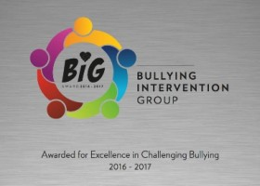
BIG Award (National Anti-Bullying award and Resources)
Join BIG to receive our online bullying reporting system for pupils (SOS), BIG Audit, regular newsletter to a named anti-bullying leader in school, resources for staff and the opportunity to gain our national award with support to guide you.
Example price for annual membership - £165 for a primary school with under 500 pupils*

Counselling
We also offer a full counselling service, for both staff and pupils. Please contact us to discuss your needs. Reduced costs for regular bookings.
Visit www.bullyinginterventiongroup.org for further information.

Training costs – 2 hour minimum sessions. No travel costs charged.
2 hours | £300
6 hr SLA | £800
12 hr SLA | £1500
Email: vicki.lydon@bigaward.org.uk | Phone: Vicki - 07870 499275

